Artist Critique: Due 10/18-10/17
Mrs. Tell/Mrs. Wallis
Directions:
- Look up Still Life art works from each of the artists listed below to visually compare their work.
  - Audrey Flack
  - Ferdnand Legar
  - Janet Fish
  - Jean Metzinger
  - Robert Jackson
  - Roberto Bernardi
  - Roy Lichtenstien
  - Wayne Thiebaud
  - William Harnett
- Choose your favorite artist and ONE of their STILL LIFE art works to critique.
- Print the artwork no larger than 3x4” in color OR in black and white and color with colored pencils.
- Complete the ARITIST CRITIQUE in your sketchbook. Use your Sketchbook Criteria page’s Critical Method as a guideline. Follow the directions and writing prompts carefully. Be thorough and thoughtful in your critique.
- This should be ONE FULL page and have a thoughtful and creative LAYOUT in your sketchbook. Look at the example pages shown below. Be neat and organized.

Still Life Artists:

Student Examples of Creative Artist Critique Sketchbook Pages:
*** The artists and artworks differ from your Artist Critique assignment!
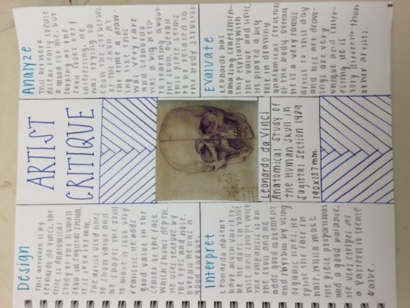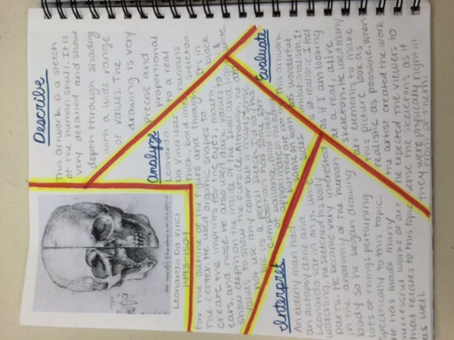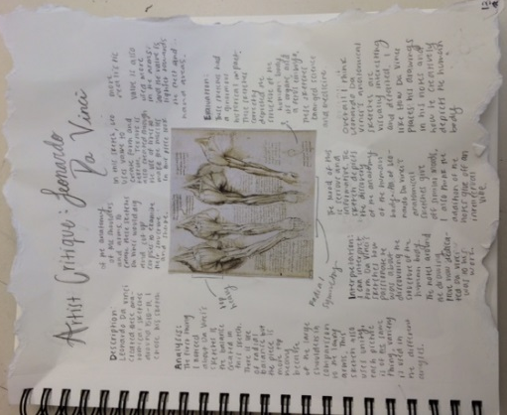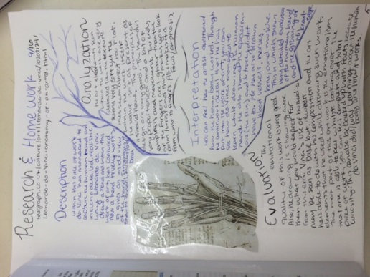

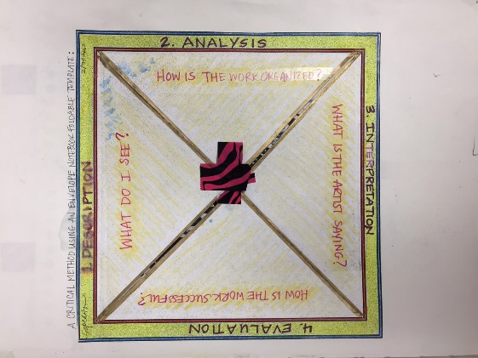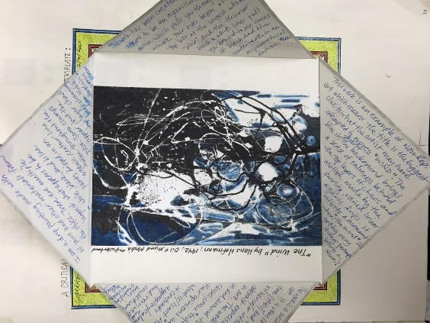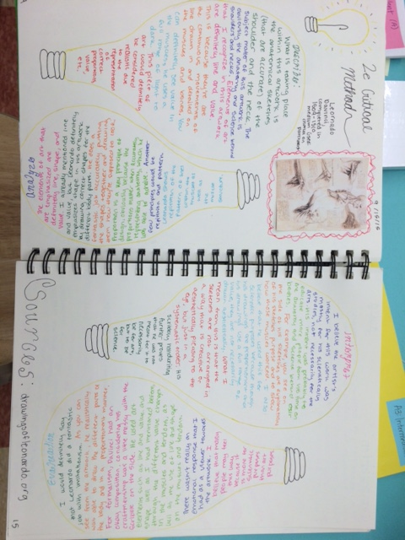
Artist Critique Foldable Example Two Page Spread (Above and Beyond!)

