- Warm-up: How can you draw a paperclip without drawing a paperclip? Write your response in your sketchbook.
- Guided Practice:
  - Set up and Label your sketchbook like the example below: (rectangles are 2” x 3” )
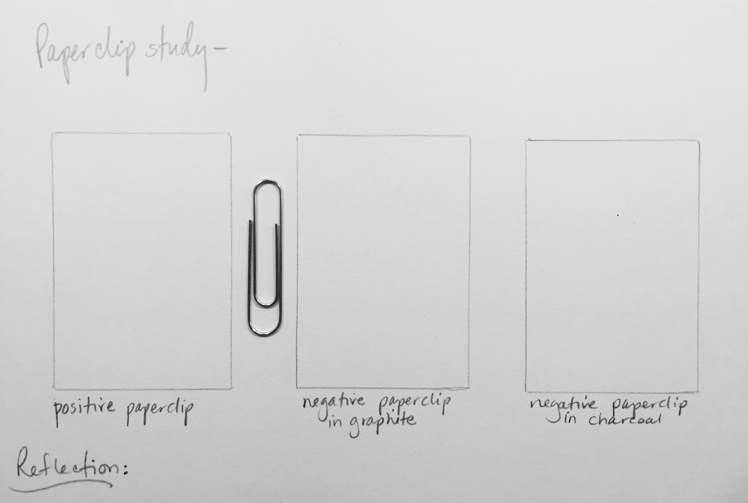
  - In the “Positive” box, look at a paperclip and draw what you see focusing on the “positive” object, the paperclip.
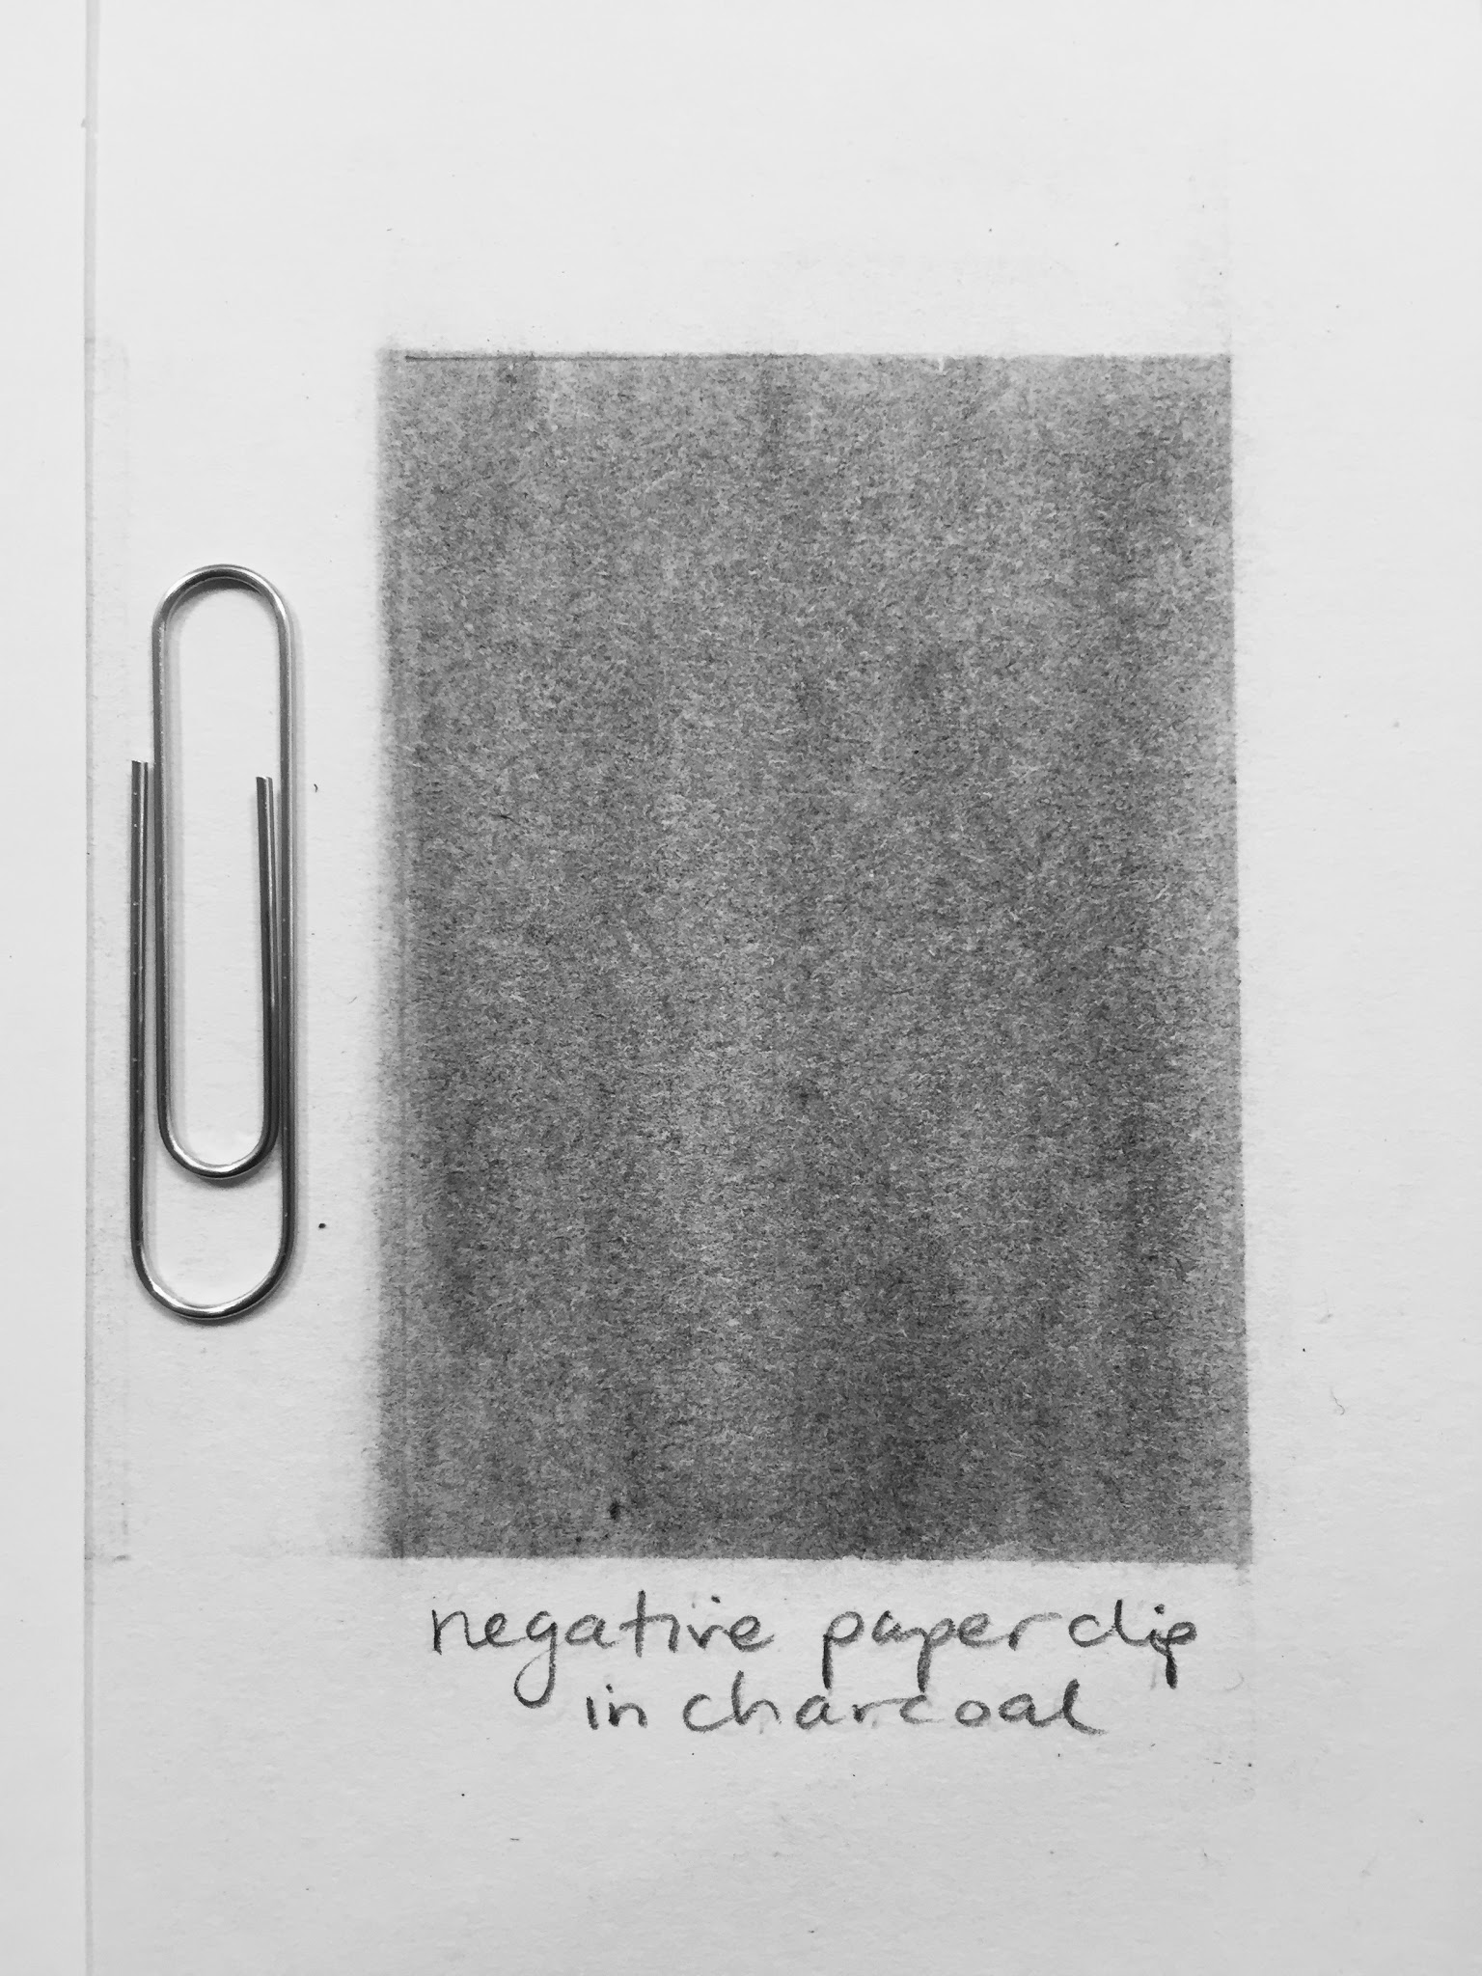
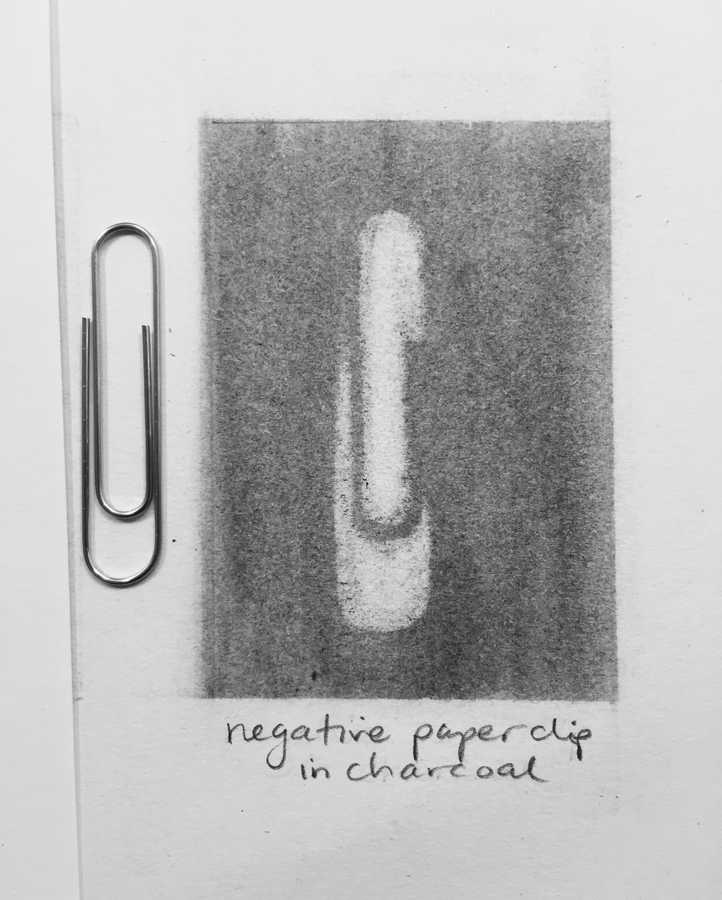
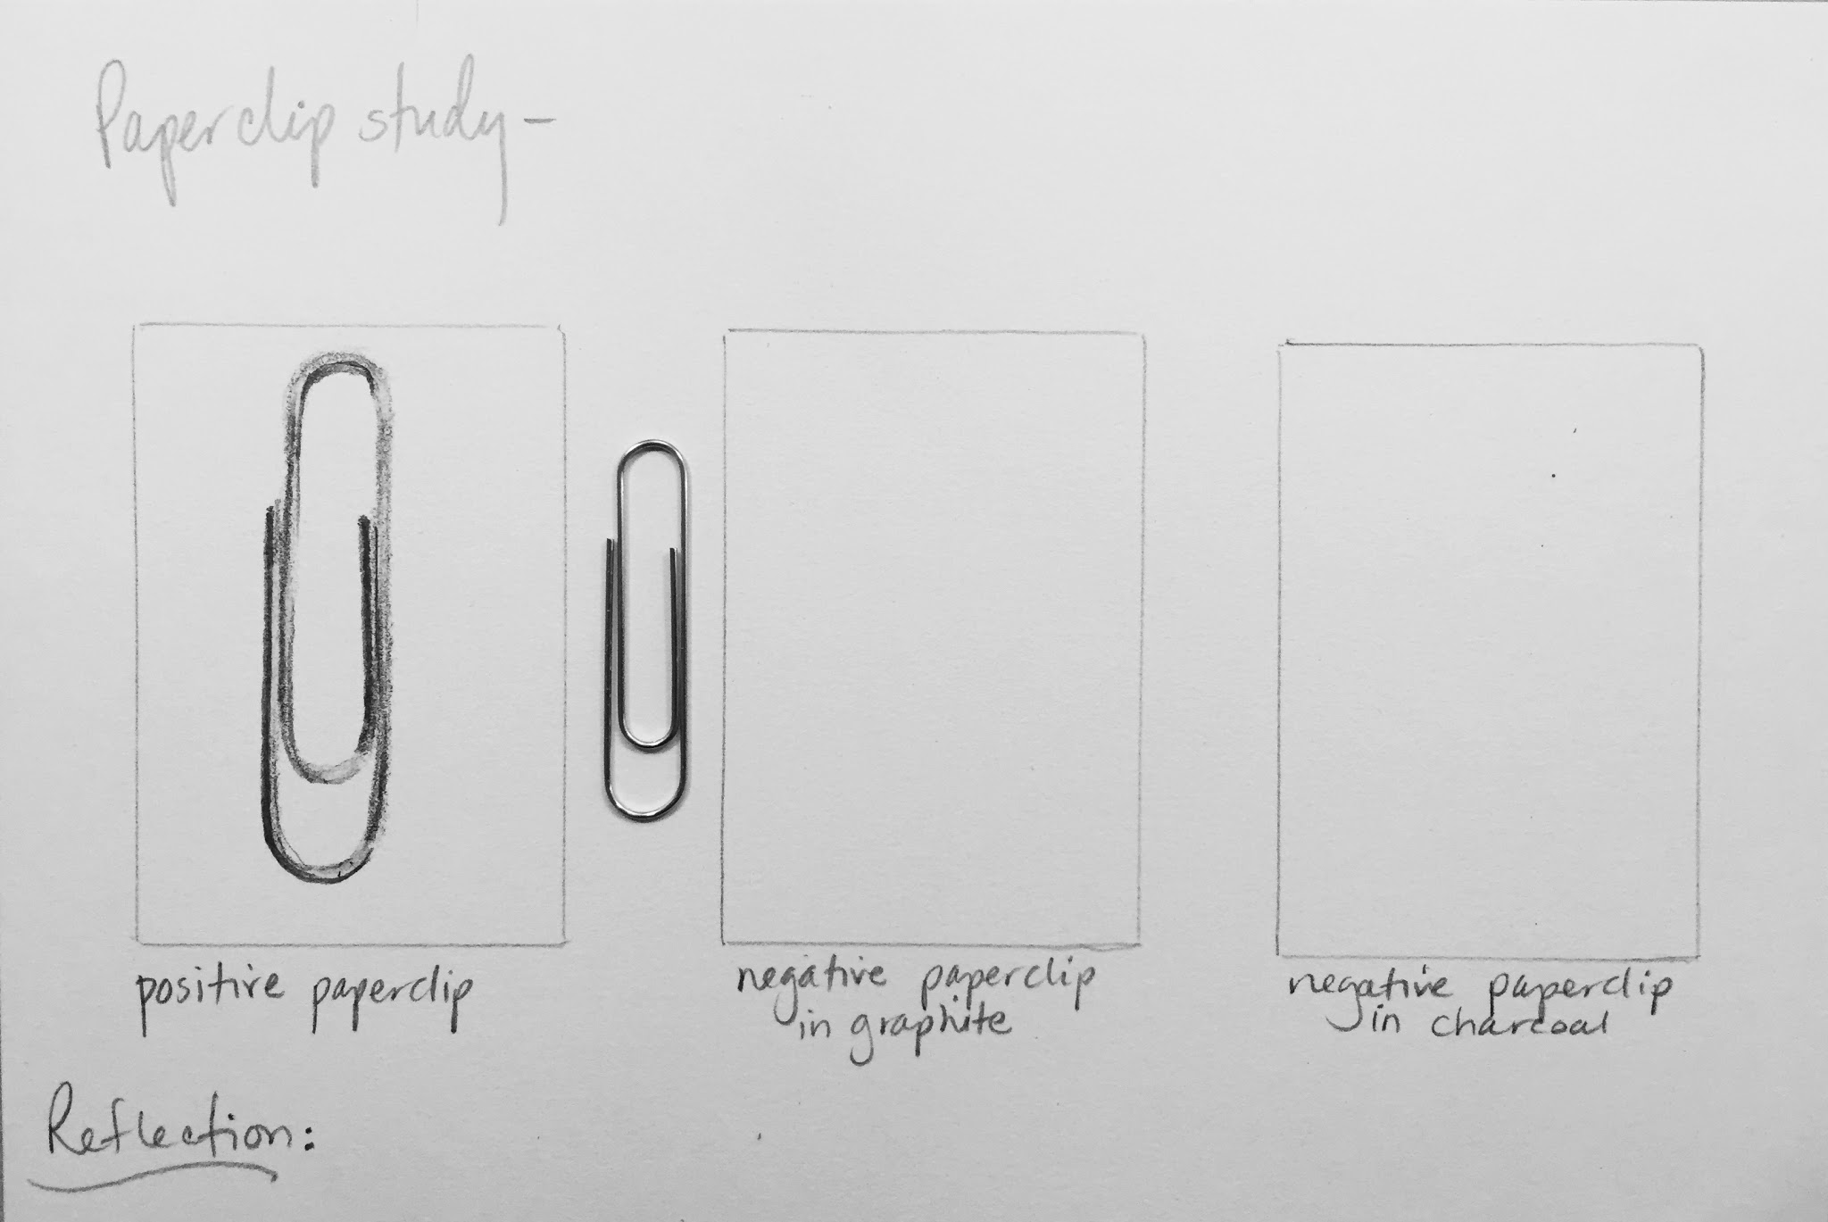
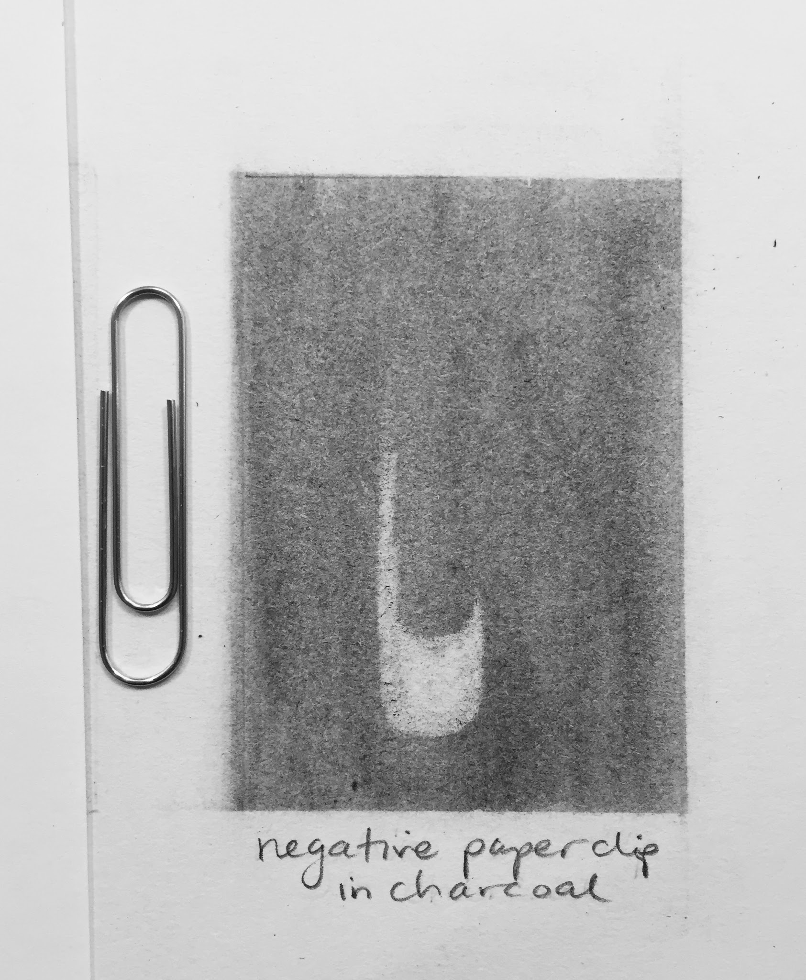
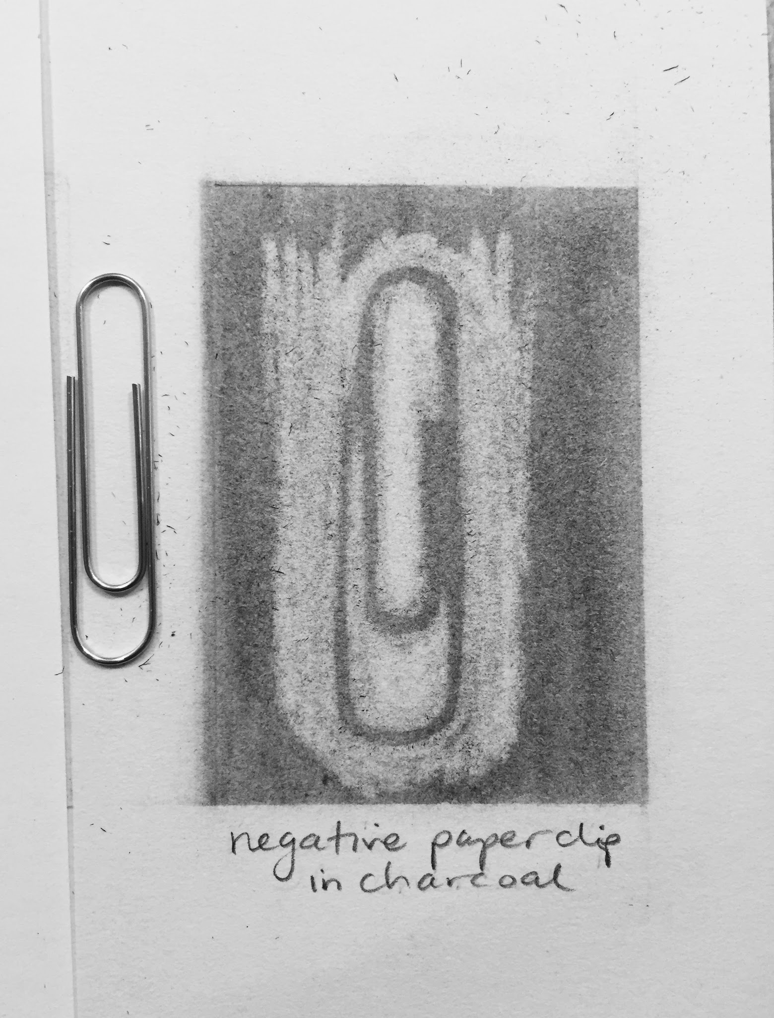
  - To set up the “Negative” boxes, shade the middle one in graphite and the last one using charcoal dust (not available at home). Use a medium value, apply even pressure, and blend for consistency. Cover up your positive study, for more focus. Next, Observe and erase the “negative” areas around the paperclip.
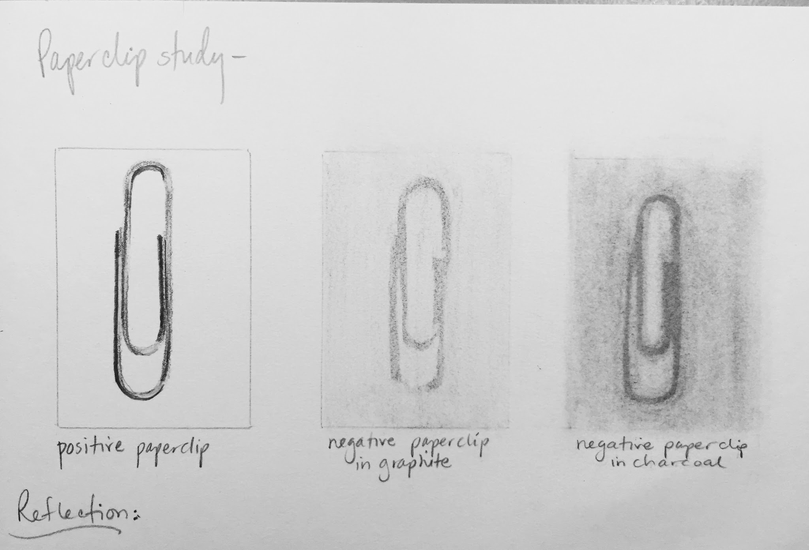
  - Reflect on the two processes--drawing the “positive” object versus shading first and erasing “negative” areas. Which method “felt” more comfortable and why? Which method has better proportions? If you struggled with the negative the first time, try it again before responding. Write your Reflection in your sketchbook.

3. Independent Practice: Apply what you learned from the paperclip study to complete a
Negative study of each of the four Features: Eye, Nose, Mouth, and Ear.

- Shade the “Negative” box next to your first feature. Use a medium #-6 value, apply even pressure, and blend for consistency. Use your #1-9 Value Scale as a reference for your study and a range of erasers if you have access to them. Cover up your “Positive” studies to focus your observation only of the magazine version.

- Turn your study upside down so the Right brain takes over. Erase the lightest lights first, which should represent #1-3 values. I used a kneaded eraser and applied more or less pressure, while molding a point with my eraser for more detailed areas.
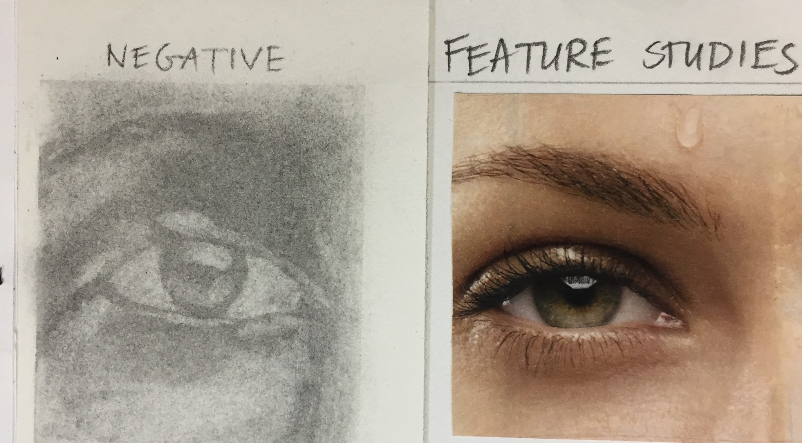
- Erase the medium values next, which should represent #4-5 values. I used an eraser pen for the tiny detailed lights in the eyebrow and under the eye for more intense detail.
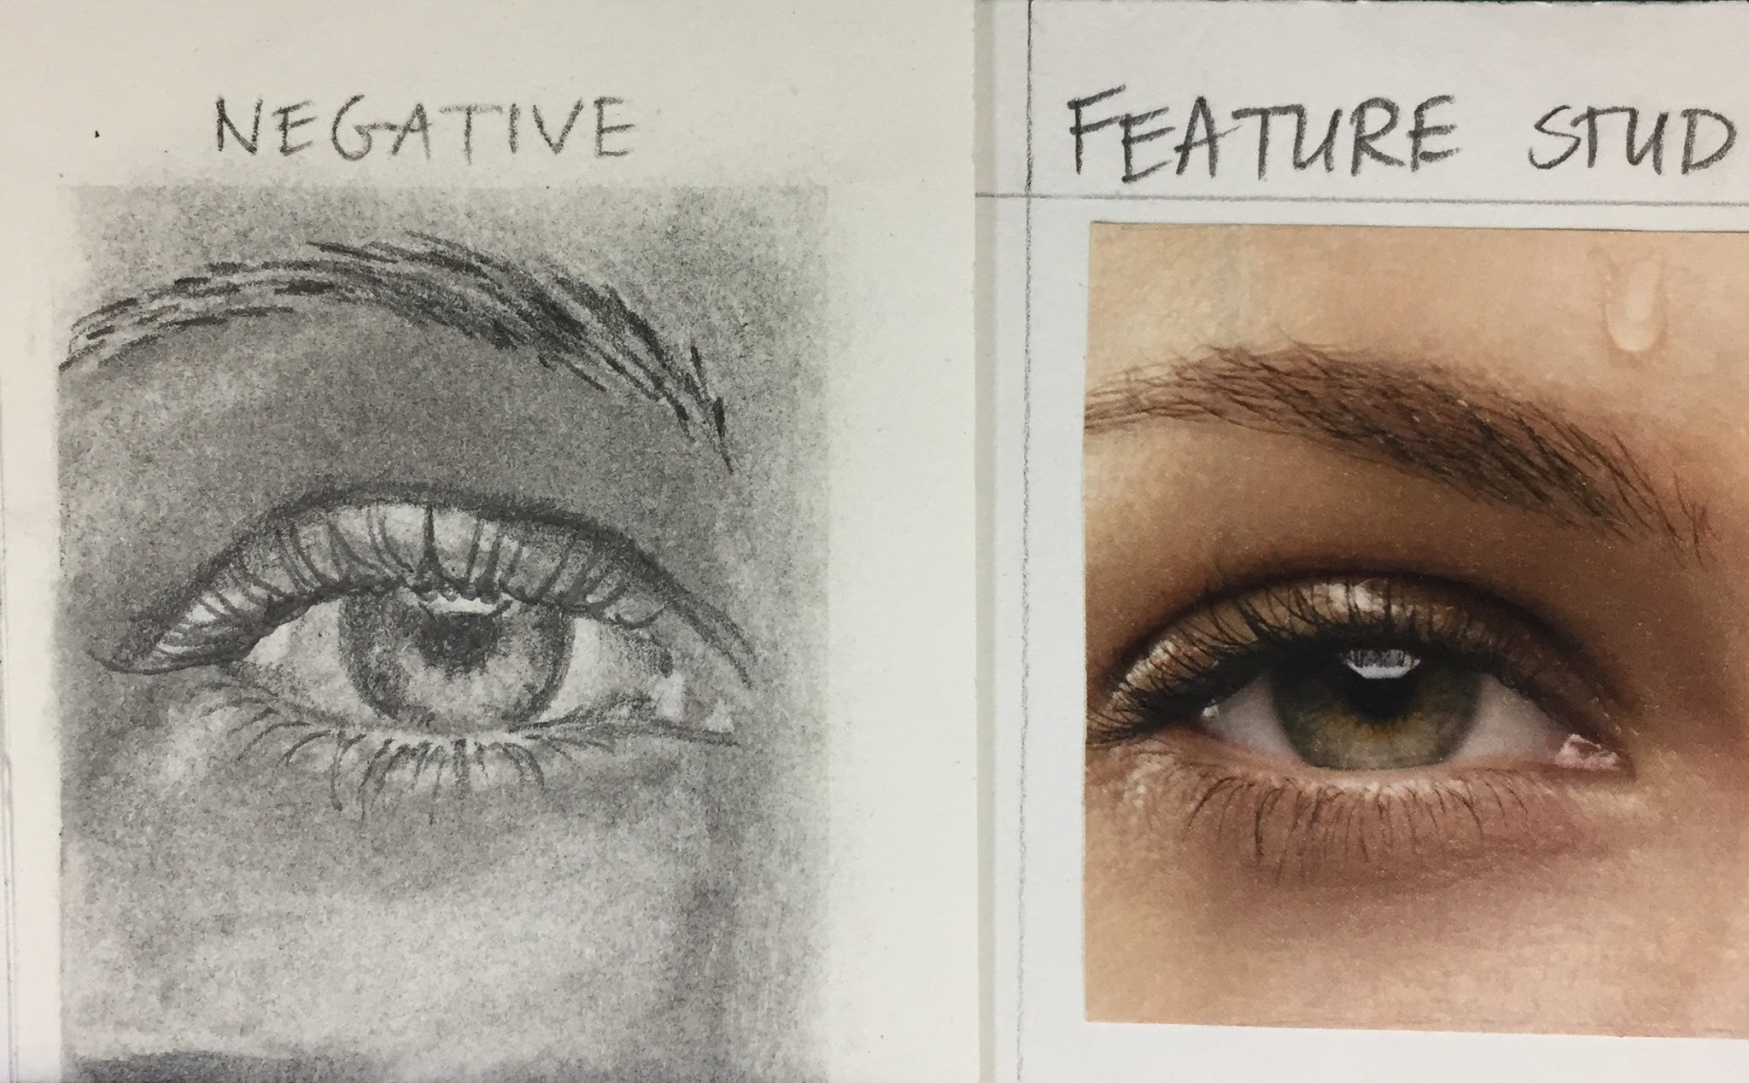
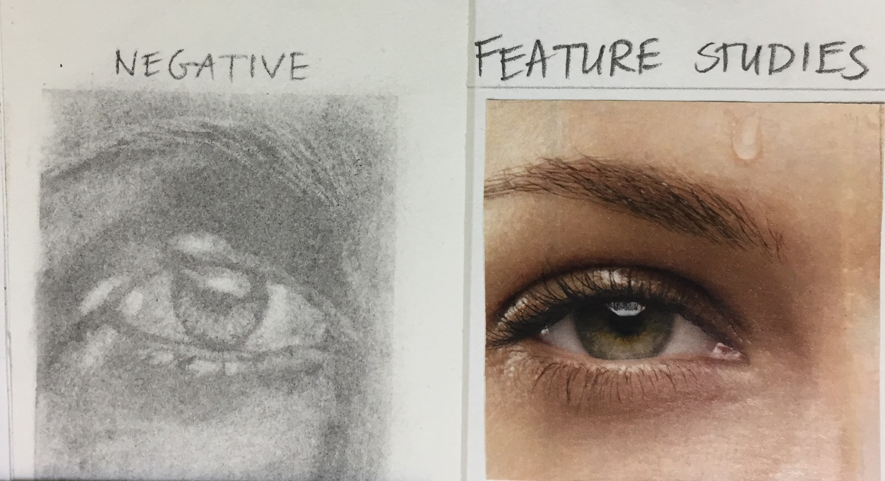
- Use a dark graphite pencil (4B, 6B or Layout pencil) to apply the darkest darks last, which represent #8-9 values.
- Flip over your drawing to reveal the finished “Negative” version.

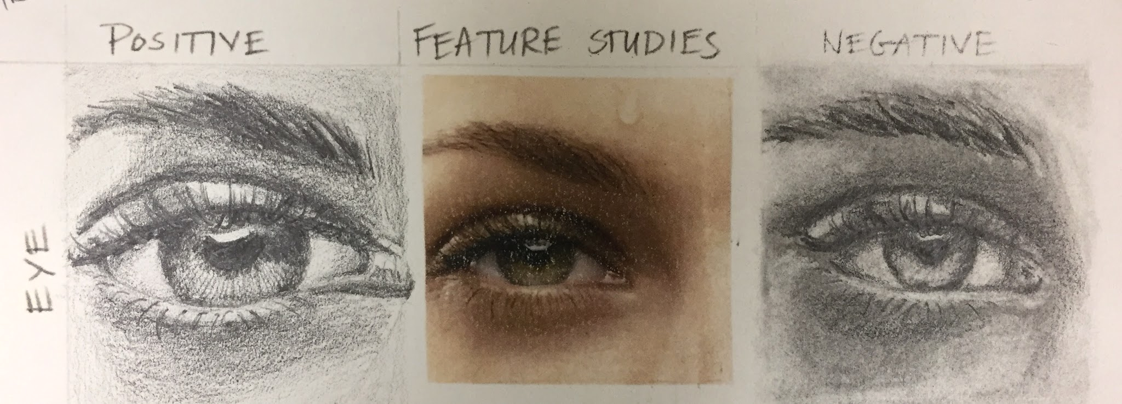
- Compare your “positive” drawing to your “negative” drawing and annotate in your sketchbook what you discover as your strengths and weaknesses; likes and dislikes with these methods.
- Continue until you complete all FOUR Feature Studies.
