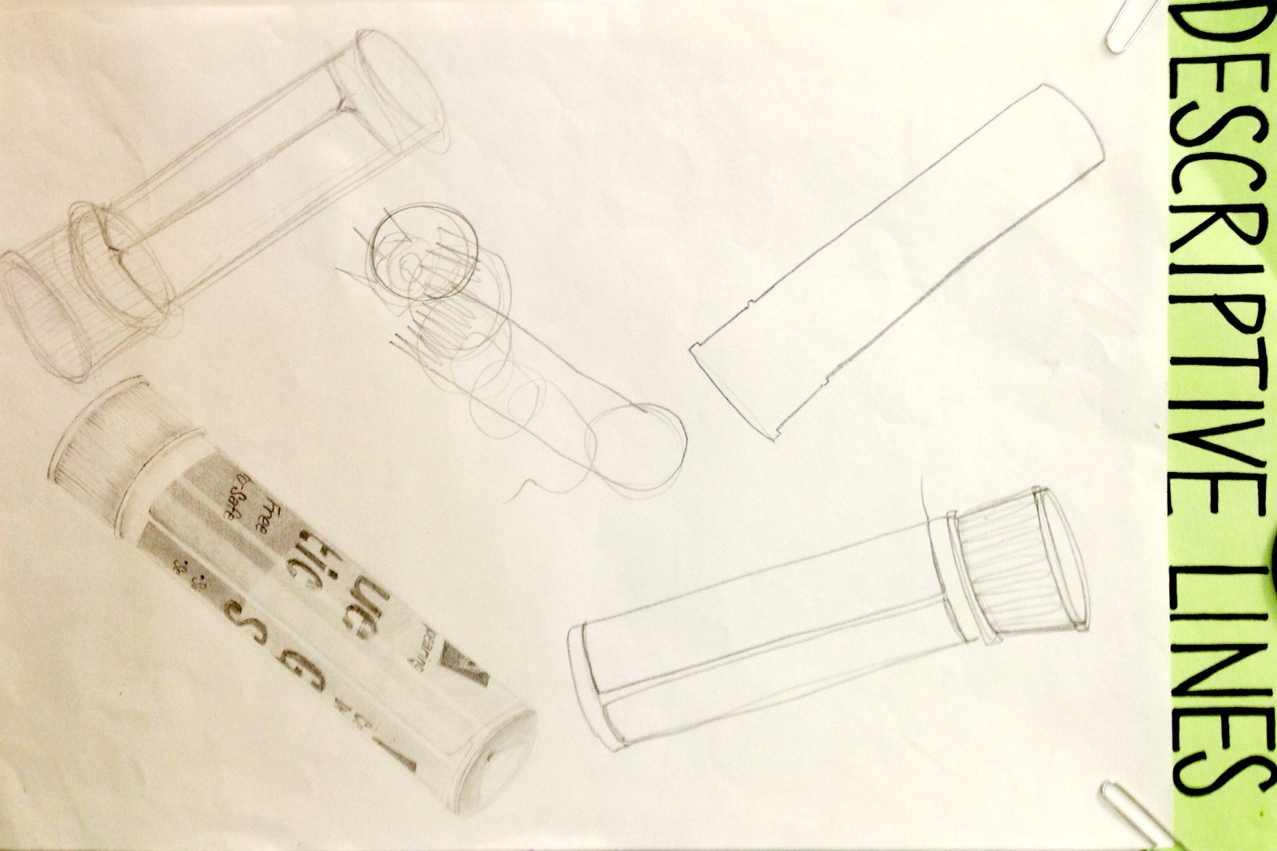

**Blind Contour Lines:** Contour lines drawn while observing the object without looking at the drawing itself.

**Outlines:**   
Define the outer edge (exterior detail) of an object. Make objects appear flat, 2-D (like shapes) and are continuous.

**Sketch Lines:**  
Define the most detail of an object. They can be modified for accuracy and should show depth with value shading and proper proportions.

**Gesture Lines:** Quick lines used to capture fluidity and movement. They are not as defined and allow for restating.

**Contour Lines:**Define interior and exterior details of an object. They are continuous—Do NOT pick up your pencil. Drag your marks, Restate and Do NOT erase!